**Project Report**

**On**

**Restaurant Management Website**

**SUBMITTED IN PARTIAL FULFILLMENT OF THE**

**REQUIREMENTS**

**FOR THE AWARD FOR "O" LEVEL COMPUTER COURSE**

Submitted To: Submitted By: -

NISHANT

Roll No:-

DEOCC O Level



DELHI INSTITUTE OF COMPUTER SCIENCE

JANAKPURI NEW DELHI

**Content**

1. **Acknowledgment**
2. **Declaration**
3. **Introduction**
   * Summary
   * Need of the Project
4. **Objective**
5. **Requirement Analysis**
   * Functional Requirements
   * Non-Functional Requirements
6. **Hardware and Software Specifications**
7. **Existing System**
8. **Proposed System**
   * Features and Benefits
9. **Implementation Details**
10. **Limitations**
11. **Conclusion**
12. **Future Enhancements**
13. **Bibliography/References**

**Acknowledgment**

I would like to express my sincere gratitude to everyone who supported me throughout the completion of this project.

First and foremost, I would like to thank **,** my mentor and instructor, for invaluable guidance, encouragement, and constructive feedback. Her continuous support and expert advice were instrumental in the successful completion of this project.

I am also thankful to **Delhi Institute of Computer Science** for providing the necessary resources and an enriching learning environment. The institute's support has played a vital role in the development of this project.

A special thanks to my friends and family for their unwavering support, motivation, and understanding throughout this journey. Their belief in me kept me motivated and focused.

Finally, I would like to acknowledge the contribution of various online resources and tutorials, which provided me with the necessary knowledge and guidance to complete this project.

Thank you all for your support and encouragement.

**DECLARATION**

I hereby declare that this project report entitled " **Restaurant Management Website** " Submitting for partial fulfilment of the requirement for the Certified O Level computer course by DEOCC. This report is only for educational purpose and not for any other purpose.

NISHANT

Roll No.

DEOCC O Level

**Introduction**

**Summary**

The "Restaurant Website" project aims to create a user-friendly platform to represent a restaurant's services, menu, and ambiance online. The website is designed with an attractive interface to provide a seamless browsing experience for customers. It includes key features such as a home page with an inviting layout, a menu showcasing available dishes, an about us section, and a table reservation system. This project leverages HTML and CSS to create a responsive, visually appealing design suitable for various devices.

The project serves as a demonstration of basic web development skills while fulfilling the functional and aesthetic needs of a modern restaurant. By providing information and a reservation system online, the website enhances customer convenience and helps the restaurant attract more visitors.

**Need of the Project**

In the modern digital era, having an online presence is crucial for businesses, including restaurants. A restaurant website offers several advantages:

1. **Accessibility**: Customers can easily find information about the restaurant, such as its menu, location, and operating hours, anytime and anywhere.
2. **Convenience**: The online reservation system allows customers to book tables quickly, enhancing their overall experience.
3. **Marketing Tool**: The website serves as a platform to showcase the restaurant’s unique features, menu items, and ambiance, attracting more potential customers.
4. **Increased Revenue**: By reaching a broader audience online, the restaurant can boost its footfall and revenue.
5. **Improved Customer Engagement**: Customers can learn about special offers or events, fostering stronger connections with the brand.

This project emphasizes the importance of a professional, accessible, and visually appealing website for restaurants, helping them stay competitive in today’s tech-driven world.

**Objective**

The main objective of this project is to design and develop a professional restaurant website that:

* Provides an attractive and user-friendly interface to display the restaurant's menu, services, and ambiance.
* Offers a table reservation system to enhance customer convenience.
* Promotes the restaurant’s unique features and engages potential customers online.
* Demonstrates the integration of web development techniques using HTML and CSS.

Top of Form

Bottom of Form

**Requirement Analysis**

**Functional Requirements**  
Functional requirements define the specific features and functions that the restaurant website must perform. These are the actions that the system should be able to carry out in order to meet the needs of users.

* **Homepage**:
  + Display an overview of the restaurant including its logo, name, and an inviting image of the restaurant or its ambiance.
  + Navigation bar with links to key sections like Home, Menu, About Us, and Reservation.
* **Menu Page**:
  + A dynamic and well-organized page listing food items, their descriptions, and prices.
  + Display images of dishes to make it more engaging.
* **About Us Page**:
  + Display the history, values, and mission of the restaurant.
* **Reservation System**:
  + Confirmation of booking with a "Table Reserved" message once the form is successfully submitted.
* **Contact Us Page**:
  + Provide contact information, including phone numbers, email, and location.

**Non-Functional Requirements**  
Non-functional requirements describe how the system should perform and set the standards for quality, usability, and security.

* **Usability**:
  + The website must have an easy-to-navigate interface with clear, concise text and intuitive layout.
* **Performance**:
  + The website should load quickly (ideally within 2-3 seconds).
  + The reservation system should handle multiple requests simultaneously without crashing.
* **Compatibility**:
  + The website must be compatible with all major web browsers (Chrome, Firefox, Safari, Edge).
  + The website should be responsive, meaning it adjusts correctly to different screen sizes and devices (smartphones, tablets, desktops).
* **Security**:
  + Secure submission of reservation details via SSL encryption to protect user information.
  + Safe handling of any personal data collected (if any) through the reservation form.
* **Availability**:
  + The website must be available 24/7, with minimal downtime. Hosting services should ensure high availability.

**Hardware and Software Specifications for Restaurant Website Project**

Here are the **hardware** and **software** specifications for your Restaurant Website project. These specifications outline the required infrastructure (hardware) and the tools or technologies (software) needed to develop and run the project.

**Hardware Specifications**

The hardware requirements for developing and running the restaurant website are fairly basic since it is a web-based project and can be run on standard desktop or laptop systems. The following are the recommended hardware specifications:

**Development Hardware (for creating the website):**

* **Processor (CPU)**:
  + Minimum: Intel i3 / AMD Ryzen 3 or equivalent.
  + Recommended: Intel i5 / i7 or AMD Ryzen 5/7 for better performance, especially while working with complex code.
* **RAM**:
  + Minimum: 4GB RAM.
  + Recommended: 8GB or higher (for smooth operation when using multiple tools or browsers simultaneously).
* **Hard Drive (Storage)**:
  + Minimum: 500GB HDD.
  + Recommended: 256GB SSD or higher for faster file access and development.
* **Graphics Card**:
  + Minimum: Integrated graphics (Intel HD Graphics or AMD equivalent).
  + Recommended: Dedicated graphics card (optional) if you plan to do design work like editing images and graphics.
* **Screen Resolution**:
  + Minimum: 1366 x 768 resolution.
  + Recommended: 1920 x 1080 or higher (Full HD) for better clarity and working with multiple windows.
* **Internet Connection**:
  + A stable internet connection with a speed of at least **10 Mbps** for efficient access to online resources, libraries, and hosting platforms.

**Software Specifications**

Here is a list of the software tools and technologies required for the development and deployment of the restaurant website:

**Development Tools (for creating the website):**

* **Text Editor or IDE (Integrated Development Environment)**:
  + **VS Code** (Visual Studio Code) – Recommended for its lightweight nature and support for HTML/CSS/JavaScript.
  + **Sublime Text** or **Notepad++** can also be used for basic coding.
* **Web Browsers**:
  + **Google Chrome** (recommended for testing the website).
* **Version Control (Optional but recommended)**:
  + **Git** – for version control.
  + **GitHub** – for storing and managing the code repository.

**Frontend Technologies:**

* **HTML5** – Used to structure content on the web.
* **CSS3** – Used for styling and layout.
* **JavaScript** – Used for interactive elements like the reservation form.

**Backend Technologies (if required for advanced features):**

* **PHP** (if server-side programming is needed for form handling or database connections).
* **MySQL** – If a database is used to store reservation information or menu details.
* **Node.js** (Optional) – For server-side JavaScript (if the project needs to be more dynamic).

**Image Editing Software (for adding images to the website):**

* **Adobe Photoshop** or **GIMP** (Open Source) for editing restaurant images, logos, and any other graphic content.

**Web Hosting & Deployment:**

* **Web Hosting Service** (e.g., **HostGator**, **Bluehost**, or **DigitalOcean** for VPS hosting).
* **cPanel** (if using shared hosting) for managing files and databases.
* **FTP Client** (e.g., **FileZilla**) for uploading files to the server.

**Database Management (if required):**

* **MySQL Workbench** or **phpMyAdmin** for managing MySQL databases (if storing reservation data).

**Existing System**

Most restaurants either lack an online presence or rely on third-party applications like Zomato and Swiggy for their digital representation. These solutions:

* Do not offer direct control over the brand’s identity and customer experience.
* Lack a personalized platform for promotions and engaging customers directly.
* Often charge significant commissions, reducing profit margins.

This project aims to overcome these limitations by providing the restaurant with its own website, ensuring better branding and customer engagement.

**Proposed System**

The **Proposed System** is an advanced, user-friendly, and interactive website designed specifically for restaurants to manage their operations and provide better services to customers. This system aims to overcome the challenges of the existing system and provide a modern solution for both restaurant owners and customers.

**Features of the Proposed System**

1. **Dynamic Homepage:**
   * Welcoming homepage with an appealing design and background image representing the restaurant's ambiance.
   * Easy navigation with links to key pages like Menu, About Us, Reservations, and Contact Us.
2. **Interactive Menu Page:**
   * Detailed menu with food categories, descriptions, prices, and appealing images of dishes.
   * Option to update the menu easily by the restaurant owner.
3. **Online Table Reservation System:**
   * A simple reservation form where users can book tables by providing their name, date, time, and contact information.
   * Instant confirmation message displayed upon successful reservation.
4. **Responsive Design:**
   * Website adapts to different screen sizes, ensuring compatibility with desktops, tablets, and smartphones.
5. **Contact Us Page:**
   * Includes the restaurant’s address, phone number, email, and a contact form for inquiries.
   * Google Maps integration for location.
6. **Modern UI/UX Design:**
   * A clean, user-friendly interface with an aesthetic color scheme to create a pleasant browsing experience.
7. **SEO-friendly Design:**
   * Optimized for search engines to improve visibility and attract more customers online.

**Benefits of the Proposed System**

1. **Improved Customer Experience:**
   * Customers can view the menu, make reservations, and contact the restaurant easily from the comfort of their homes.
2. **Time Efficiency:**
   * The online reservation system eliminates the need for manual booking, saving time for both staff and customers.
3. **Increased Accessibility:**
   * A responsive website ensures that customers can access the system on any device, increasing convenience.
4. **Enhanced Marketing Reach:**
   * Having an online presence allows the restaurant to attract a wider audience and promote its services effectively.
5. **Reduced Operational Errors:**
   * Automating table reservations and customer inquiries minimizes human errors, ensuring smoother operations.
6. **Cost-Effective Solution:**
   * Eliminates dependency on third-party platforms, saving commission costs and allowing direct customer interaction.
7. **Scalability:**
   * The system can be expanded to include features like online ordering or loyalty programs in the future.

**Implementation Details**

**Brief Introduction**

This section demonstrates the implementation of the Restaurant Website project, showcasing the practical realization of the proposed system. The implementation involves the development of a fully functional website using HTML, CSS, and JavaScript for frontend design, along with integration of dynamic features like an interactive menu and a table reservation system.

Through screenshots and explanations, this section provides a detailed view of the website’s core features and layout, highlighting the user interface and the functionality of various components such as the homepage, menu page, reservation form, and confirmation system. Each screenshot is accompanied by a description to give a clear understanding of how the system operates and fulfils the objectives set out in the project proposal.

**Index HTML CODE**

**<!DOCTYPE html>**

**<html>**

**<head>**

**<meta charset="UTF-8">**

**<meta name="viewport" content="width=device-width, initial-scale=1.0">**

**<title>Basic B Burgers 🍔</title>**

**<link rel="stylesheet" href="style.css">**

**</head>**

**<body>**

**<header>**

**<div class="logo">Basic B Burgers 🍔</div>**

**<nav>**

**<ul>**

**<li><a href="#home">Home</a></li>**

**<li><a href="#about">About Us</a></li>**

**<li><a href="#menu">Menu</a></li>**

**<li><a href="#contact">Contact</a></li>**

**</ul>**

**</nav>**

**</header>**

**<section id="home" class="hero-section">**

**<div class="hero-content">**

**<h1>Welcome to Basic B Burgers 🍔</h1>**

**<p>Your neighborhood cafe for delicious bites and a warm ambiance.</p>**

**<button onclick="reserveTable()" id="reserveButton">Reserve a Table</button>**

**<p id="reservationMessage" style="display: none; color: #fff; font-size: 1.2em; margin-top: 10px;"></p>**

**</div>**

**</section>**

**<section id="about" class="hero-section">**

**<div class="hero-content">**

**<h2>About Us</h2>**

**<p>Basic B Burgers 🍔 offers a warm, casual dining experience with a variety of delicious meals and beverages. Perfect for a quick snack or a leisurely meal.</p>**

**</div>**

**</section>**

**<section id="menu">**

**<div class="menu-content">**

**<h1>Our Menu</h1>**

**</div>**

**<div class="menu-grid">**

**<div class="menu-item">**

**<img src="images/burger.jpg" alt="Burger">**

**<h3>Classic Burger🍔</h3>**

**<p> ₹149 - Spicy Paneer Burger with Fresh Coriander and Tangy Mint Chutney.</p>**

**</div>**

**<div class="menu-item">**

**<img src="images/pasta.jpg" alt="Pasta">**

**<h3>Red Sauce Pasta🍝 </h3>**

**<p>₹199 - Creamy Alfredo Pasta with Fresh Herbs and Garlic Bread.</p>**

**</div>**

**<div class="menu-item">**

**<img src="images/salad.jpg" alt="Salad">**

**<h3>Margherita Pizza🍕</h3>**

**<p>₹249 - Margherita Pizza with Fresh Basil and Melted Mozzarella.</p>**

**</div>**

**</div>**

**</section>**

**<section id="contact" class="hero-section">**

**<div class="hero-content">**

**<h2>Contact Us</h2>**

**<p>Address: Shop no.5 Tilak Nagar New Delhi 110064</p>**

**<p>Phone: +91 9900112255 </p>**

**<p>Email: BasicBBurgers@gamil.com</p>**

**</div>**

**</section>**

**<footer>**

**<p>&copy; 2024 Basic B Burgers 🍔. All rights reserved.</p>**

**</footer>**

**<script>**

**function reserveTable() {**

**document.getElementById('reserveButton').style.display = 'none';**

**const message = document.getElementById('reservationMessage');**

**message.innerText = "Your Table is reserved! Thank you for choosing Basic B Burgers 🍔.";**

**message.style.display = 'block';**

**}**

**</script>**

**</body>**

**</html>**

**STYLE CSS CODE**

**body {**

**font-family: Arial, sans-serif;**

**margin: 0;**

**color: #333;**

**background-color: #f4f4f4;**

**background-image: url('images/restaurant-background.jpg');**

**background-size: cover;**

**background-position: center;**

**background-attachment: fixed;**

**background-repeat: no-repeat;**

**}**

**header {**

**background-color: #3d3d3d;**

**color: #fff;**

**padding: 10px 20px;**

**display: flex;**

**justify-content: space-between;**

**align-items: center;**

**}**

**header .logo {**

**font-size: 1.5em;**

**font-weight: bold;**

**}**

**nav ul {**

**list-style-type: none;**

**padding: 0;**

**display: flex;**

**}**

**nav ul li {**

**margin: 0 15px;**

**}**

**nav ul li a {**

**color: #fff;**

**text-decoration: none;**

**}**

**.hero-section {**

**background-image: url('images/restaurant-background.jpg');**

**background-size: cover;**

**background-position: center;**

**background-attachment: fixed;**

**padding: 80px 20px;**

**text-align: center;**

**color: #fff;**

**position: relative;**

**z-index: 1;**

**}**

**.hero-content {**

**max-width: 800px;**

**margin: 0 auto;**

**padding: 20px;**

**background-color: rgba(0, 0, 0, 0.6);**

**border-radius: 10px;**

**z-index: 2;**

**}**

**.hero-section h1 {**

**font-size: 2.5em;**

**margin: 0;**

**}**

**.hero-section p {**

**font-size: 1.2em;**

**margin-top: 10px;**

**}**

**.hero-section button {**

**background-color: #ff7f50;**

**color: #fff;**

**padding: 10px 20px;**

**font-size: 1em;**

**border: none;**

**cursor: pointer;**

**}**

**section {**

**padding: 40px 20px;**

**text-align: center;**

**}**

**#menu .menu-grid {**

**display: flex;**

**justify-content: center;**

**flex-wrap: wrap;**

**gap: 30px;**

**}**

**.menu-item {**

**background-color: rgba(0, 0, 0, 0.6);**

**color: #fff;**

**padding: 20px;**

**width: 250px;**

**text-align: center;**

**border-radius: 10px;**

**box-shadow: 0px 0px 10px rgba(0, 0, 0, 0.2);**

**margin:0;**

**}**

**.menu-item img {**

**width: 250px;**

**height: 250px;**

**border-radius: 8px;**

**margin-bottom: 15px;**

**object-fit: cover;**

**}**

**.menu-item h3 {**

**margin: 10px 0;**

**}**

**.menu-item p {**

**font-size: 1.1em;**

**}**

**footer {**

**background-color: #3d3d3d;**

**color: #fff;**

**text-align: center;**

**padding: 15px;**

**margin-top: 20px;**

**}**

**#about, #menu, #contact {**

**color: #fff;**

**}**

**#about h2, #menu h2, #contact h2 {**

**color: #fff;**

**}**

**#about p, #menu p, #contact p {**

**color: #fff;**

**}**

**.menu-content{**

**max-width: 200px;**

**margin: 0 auto;**

**padding: 8px;**

**background-color: rgba(0, 0, 0, 0.6);**

**border-radius: 10px;**

**z-index: 2;**

**}**

**IMAGES OF WEBSITE**

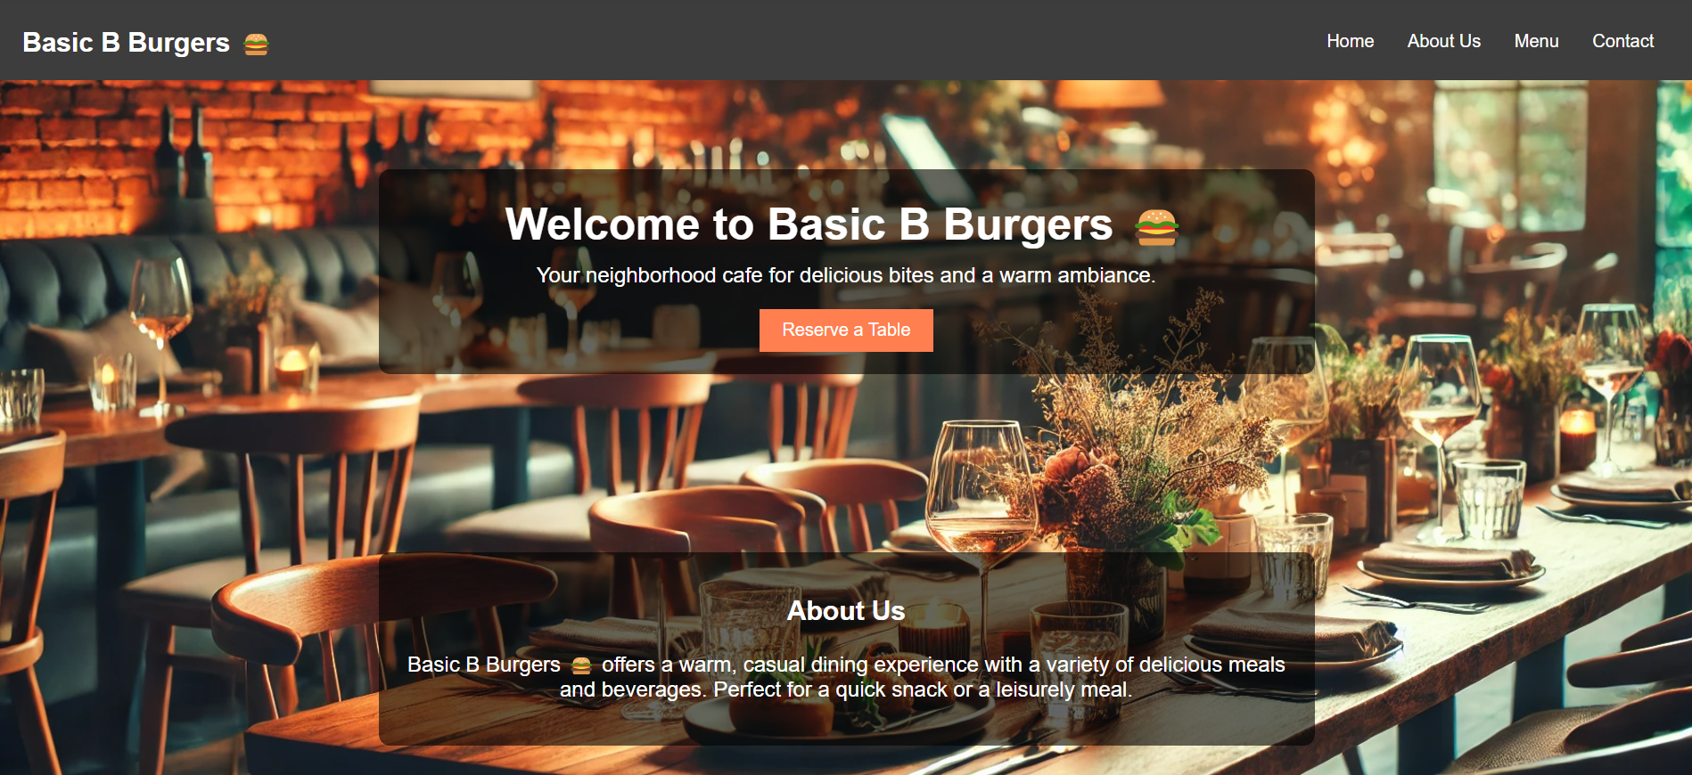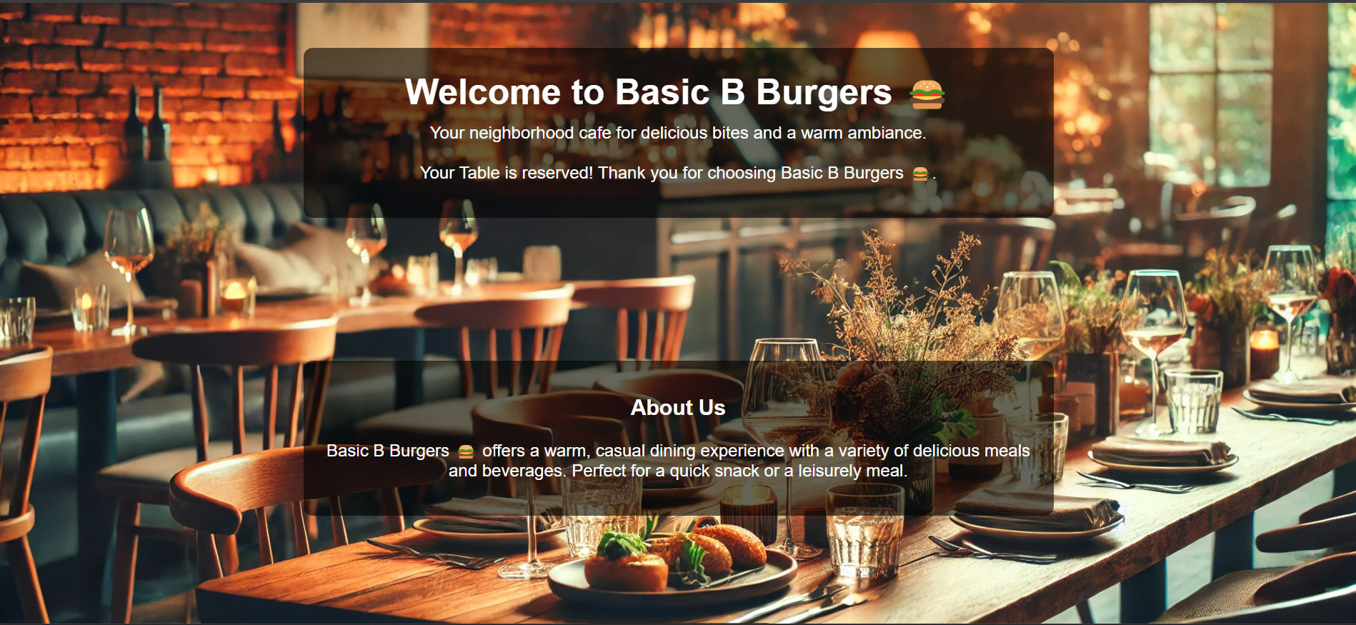

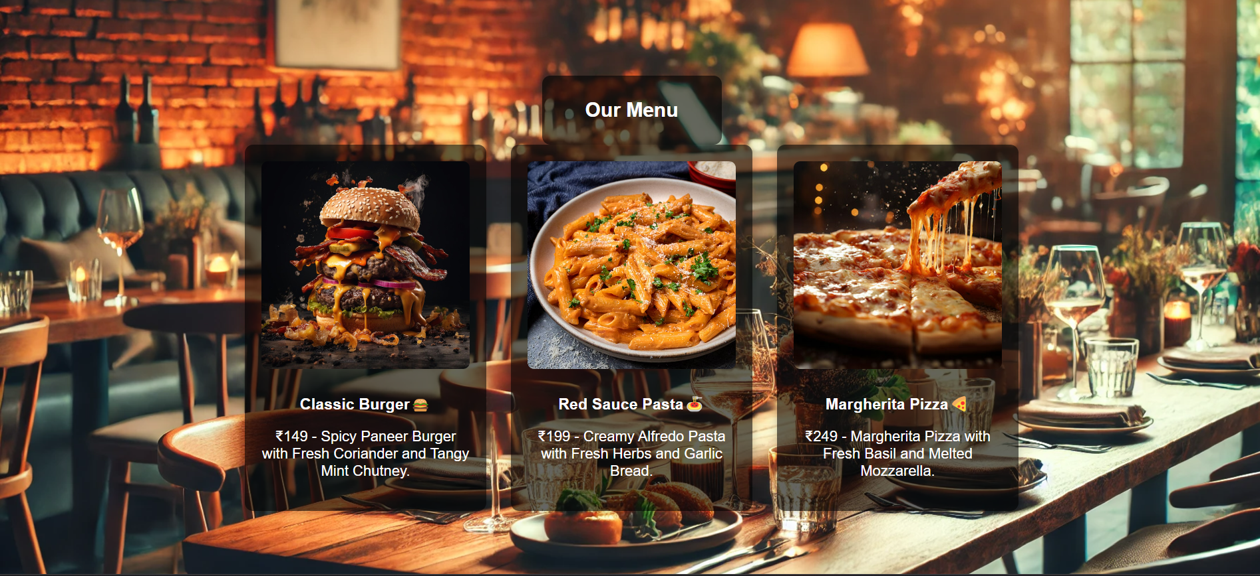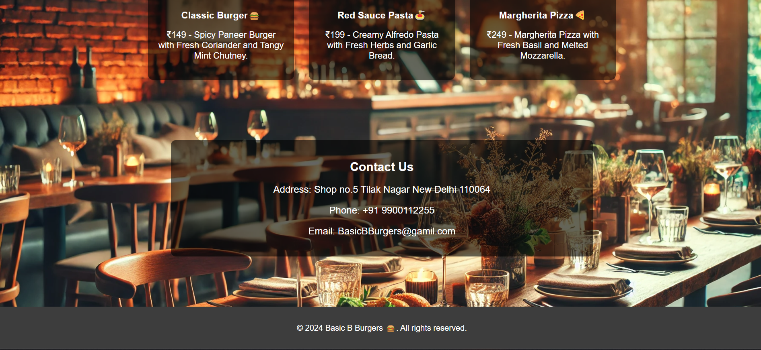

**Limitations**

1. **No Online Payment Integration:**
   * The system does not include a feature for online payments, which could enhance the reservation process for customers preferring prepaid options.
2. **Limited Dynamic Content:**
   * While the website is functional, it lacks a database backend to dynamically update content like the menu or reservation records.
3. **Scalability Issues:**
   * The current design is suitable for small to medium-sized restaurants. Larger businesses may require additional features such as inventory management or detailed customer analytics.
4. **Dependency on Manual Updates:**
   * Adding or editing menu items, prices, or other content requires manual code updates, which may not be convenient for non-technical users.
5. **No User Authentication:**
   * The website does not have a login or user authentication system for customers or administrators, limiting security and personalized experiences.
6. **Absence of Analytics:**
   * The project does not provide tools to analyse customer data, such as reservation trends or popular menu items, which could help the restaurant make data-driven decisions.
7. **Basic Reservation System:**
   * The reservation system lacks advanced features such as real-time availability updates or the ability to manage cancellations and modifications.
8. **Limited Accessibility Features:**
   * The website does not fully adhere to accessibility standards (e.g., for visually impaired users), which may restrict its usability for all customers.
9. **Offline Functionality:**
   * The system is entirely web-based and requires an internet connection to function. Offline accessibility is not supported.
10. **Limited Language Support:**
    * The website currently supports only one language, making it less inclusive for a diverse customer base.

**Conclusion of this Project**

The development of the restaurant website marks a significant step toward modernizing the dining experience for both customers and restaurant owners. By integrating features such as an interactive menu, an online table reservation system, and a responsive design, the website provides an efficient and user-friendly platform to meet customer expectations in today's digital age.

This project has successfully addressed the challenges of traditional systems, such as manual reservations and limited reach, by offering a dynamic and accessible solution. The implementation of this website not only improves operational efficiency for the restaurant but also enhances customer satisfaction by providing convenience and a seamless online experience.

While the project achieves its primary objectives, there is room for future enhancements, such as integrating online payment systems, adding real-time reservation updates, and expanding to support multiple languages. These improvements can make the system even more robust and scalable to cater to a wider audience.

In conclusion, the restaurant website project demonstrates the potential of technology to revolutionize traditional processes, offering a strong foundation for future growth and innovation in the hospitality industry.

**Future Enhancements the Project**

1. **Online Payment Integration:**
   * Adding a secure online payment gateway to allow customers to prepay for reservations or meals. This will make the system more convenient and professional.
2. **Real-Time Reservation Management:**
   * Incorporating real-time table availability updates to let customers view and book tables instantly without manual confirmation.
3. **Dynamic Menu Management:**
   * Implementing a database backend to enable restaurant owners to easily update menu items, prices, and images without requiring code changes.
4. **Multi-Language Support:**
   * Adding multi-language support to cater to a diverse customer base and improve accessibility for non-English speakers.
5. **User Authentication and Profiles:**
   * Creating a login system where customers can register, save their preferences, and view their booking history.
6. **Mobile Application Development:**
   * Extending the system into a dedicated mobile app for even greater accessibility and user engagement.
7. **Advanced Analytics:**
   * Integrating analytics tools to track customer behaviours, reservation trends, and popular menu items, helping the restaurant make data-driven decisions.
8. **Review and Feedback System:**
   * Adding a feature for customers to leave reviews or feedback on their dining experience, helping the restaurant improve its services.
9. **Push Notifications and Email Alerts:**
   * Enabling automatic notifications to remind customers of their reservations or inform them of new offers and discounts.
10. **Accessibility Features:**
    * Enhancing the website to meet accessibility standards, including support for screen readers and keyboard navigation for differently-abled users.
11. **Loyalty Program Integration:**
    * Introducing a customer loyalty program where users can earn points for frequent visits or reservations, encouraging repeat business.
12. **Integration with Delivery Services:**
    * Adding functionality for online food ordering and delivery integration to broaden the restaurant’s service offerings.

**Bibliography/References**

1. **Books and Guides:**
   * *HTML and CSS: Design and Build Websites* by Jon Duckett
   * *JavaScript and JQuery: Interactive Front-End Web Development* by Jon Duckett
2. **Online Resources:**
   * W3Schools: <https://www.w3schools.com>
   * MDN Web Docs: <https://developer.mozilla.org>
3. **Tools and Platforms Used:**
   * Visual Studio Code: <https://code.visualstudio.com>
   * Unsplash (Images): <https://unsplash.com>
4. **Support and Guidance:**
   * , Department of Computer Science, DICS Computer Education.